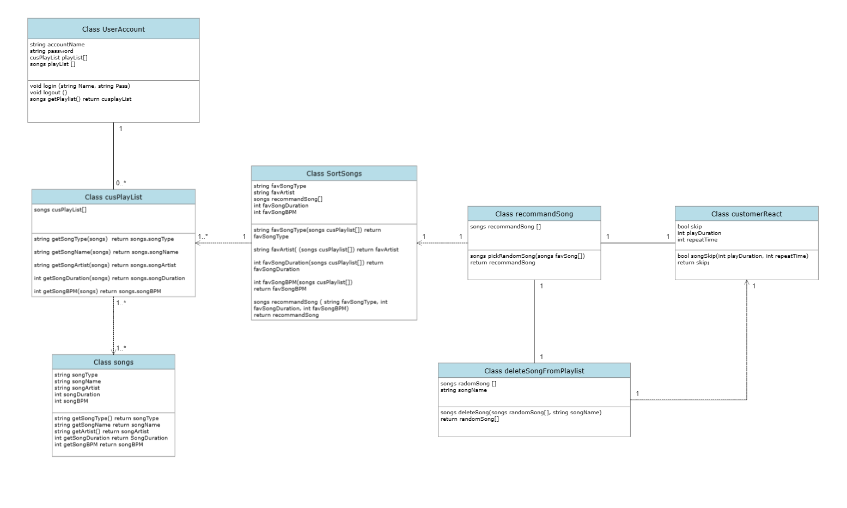

1. Each user can create a class UserAccount. This class contains an accountName type string, a password type string, as well as an array of playlist and songs. The user can perform functions such as login, which takes the entered name and password as parameters and compare them with the existing accountName and password stored in account. In addition, user can choose to logout, which requires no parameter, and view playlist, which take no parameter and return all the created playlist.
2. A UserAccount class can have multiple cusPlaylist. A cusPlaylist contains an array of songs which was added by the user. The cusPlaylist can perform many getter operations such as getSongType, getSongName, getSongArtist, getSongDuration, and getSongBPM. These operations take the requested song in the playlist as parameter.
3. Each song in the library belongs to the songs class. A songs class contains a songType, songName, and songArtist of type string, as well as songDuration and songBPM of type int. The songs class can perform getters functions such as getSongType, getSongName, getSongArtist, getSongDuration, and getSongBPM without taking any parameters.
4. The AI playlist generator can sort through a user’s playlist using the SortSongs class. This class contains a favSongType and favArtist of type string; an array name favSong of class songs; a favSongDuration and favSongBPM of type int. The SortSongs class can performs the following operations based on an array of cusPlayList as parameter:
   1. favSongType, which return the string favSongType
   2. favArtist, which return the string favArtist
   3. favSongDuration, which return the int favSongDuration
   4. favSongBPM, which return the int favSongBPM

In addition, the SortSongs class can perform recommend song operation, which takes all of the class’s attribute and return a recommendSong of class songs

1. The class recommendSong will help the AI generator keep tracks of all the recommended songs to the user. The class contains an array of recommendSong of type songs and has an operation pickRandomSongs, which take an array of songs as parameter and return a random song in that array.
2. The AI generator can take into account the user’s reaction using the class custormerReact. It contains attributes such as skip of type bool, playDuration of type int, and repeatTime of type int. The class contain an operation songSkip, which determined if the user is interested in listening to the current song or not. The operation takes playDuration and repeatTime as parameter and will return true if both integers fall below a certain threshold.
3. The AI generator can refine its recommendations by using the class deleteSongFromPlaylist, which contains an array of songs as well as a string of a song’s name to be deleted. The AI will determine if a song need to be removed from the recommended list by using the result from the class customerReact. To remove an unsuitable song, the operation deleteSong will be called, which will take an array of songs and the string songName. The operation will return a new array without the deleted song. After this, the array of songs will be passed back to the class recommendSong.